ESTIMATION OF BUSINESS EXPENSES

PROJECT REPORT

1.Introduction

* 1. **Overview**

This involves estimating all the expenses required to start and operate the business, such as equipment, rent, inventory, and marketing. By calculating these costs upfront, business owners can better plan their budget and avoid unexpected expenses.

* 1. ***Purpose***

Estimates are important because they allow businesses to set expectations for their customers.

They also help businesses determine whether or not a project is feasible and how much proﬁt they can expect to make. Estimating also allows businesses to plan for unforeseen expenses and keep track of

spending.

**2.Problem deﬁnition& Design Thinking**

* 1. **Empathy map**

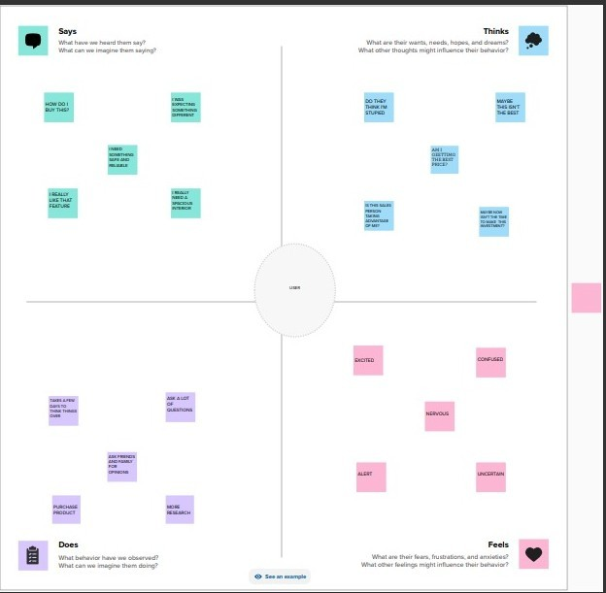

* 1. Brainstorming Map

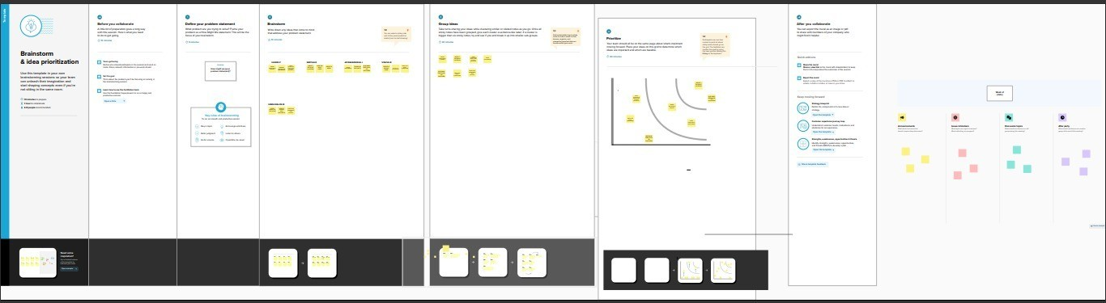

**3.Result**

When it comes to accurate estimation units for your business, there is no better way to go about it than taking the time to do it right. By ensuring you have a good grasp of the project, you will be able to provide your customers with the best service possible.

**4.Advantages**

* Budget Planning
* Resource Allocation

*Risk Management

*Improved Decision-Making

* Competitive Advantage

*Building stronger client relations

*Prior Prediction

*Budget Planning

*Resource Allocation

* Risk Management

Disadvantages

*Costing methods are typically not useful for ﬁguring out tax liabilities, which means that cost accounting can't provide a complete analysis of a company's true costs.

*Special Considerations

*Reliance on Highly-Skilled Talent

*Additional Steps to Verify Accuracy

**5.Application**

This involves estimating all the expenses required to start and operate the business, such as equipment, rent, inventory, and marketing. By calculating these costs upfront, business owners can better plan their budget and avoid unexpected expenses.

**6.Conclusion**

Businesses of every size and type need accurate estimates from their project managers to help allocate and develop budgets, resources, and different project duration. However, without an accurate estimating process, businesses are left to rely on gut

instincts and guesswork to allocate resources and manage Project.

**7.Future Scope**

As a starter in estimation , you would be

required to work under a contractor or manage a sub contractor. Initial scope may be not too promising, as many Diploma holders can easily do estimation.

However , A keen understanding of the estimation can help you , when you elevate to the level of Construction manager. That is a position that really Pays.